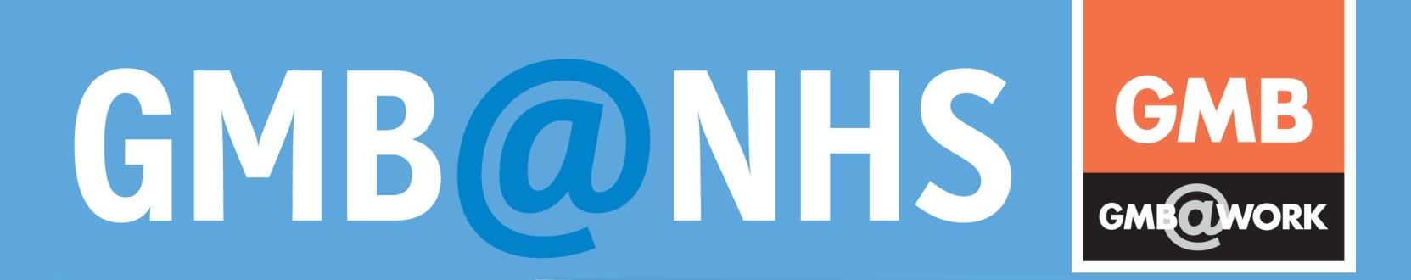
9 March 2016
NHS PAY REVIEW BODY ANNOUNCE A 1% UPLIFT ON PAY FOR ALL PAY POINTS

NHSPRB Twenty-Ninth Report 2016 has been published full details can be found at:
https://www.gov.uk/government/uploads/system/uploads/attachment_data/file/506030/54488_Cm_9210_NHS_PRB_2016_Web_Accessible_NEW.PDF
The main recommendation includes a 1% pay uplift for all Agenda for Change staff across the UK. The recommendation also includes a 1% increase to the High Cost Area Supplement minimum and maximum payments.
The NHS PRB also noted the additional aspects of public sector pay policy in Scotland (£400 minimum payment for staff earning under £22,000 and application of the Scottish Living Wage) and Wales (application of the Living Wage).
In response to the separate evidence given by the GMB and other unions for the ambulance service the NHS PRB noted a number of additional observations:
- The NHS PRB do not believe the case has been made to warrant the introduction of a national recruitment and retention premium (RRP) for paramedics. However they have accepted that there are some shortages, but that they appear to be localised and short-term, and therefore local RRP may offer a better potential targeted solution.
- There NHS PRB have recognised that there are wider recruitment, retention and engagement issues that need to be addressed holistically and have urged all parties to work together quickly to identify solutions and best practice for trusts.
- The NHS PRB have recognised that the Agenda for Change banding position of paramedics is presenting a problem and is taking too long to resolve. The PRB have recommended that a clear and tight timetable needs to be agreed between the parties with an aim to reach a final decision to minimise the negative effects of ongoing uncertainty on recruitment, retention and motivation of staff.
- The NHS PRB have also recognised that NHS England should provide central ownership and capacity to support the evolution of the future paramedic role, the identification of costs and benefits for health systems, and support the business case for any pay band changes to assist local level decision making.

GMB Ambulance Committee have responded swiftly to the above and recently launched the fair banding campaign across the Ambulance Service.
The GMB opposes the pay restraint set out by government across the Public Sector. The GMB continues to make the case that derisory pay uplifts such as the one for 2016/7 remain unacceptable to GMB members. The GMB also continues to campaign to retain hard fought terms and conditions for Agenda for Change Staff.

Rehana Azam, GMB NHS Officer commented as follows:
“GMB members are disappointed that pay restraint continues for a further year in the NHS. GMB members are angered that the government continues to lean on the NHS independent pay review body to restrict any pay awards within a derisory 1% remit. Without any flexibility afforded to the NHS pay review body, the 1% was the least to be expected.
Secretary State for Health may have approved the 1% pay uplift for 2016/17 for NHS staff but this will be cancelled out immediately as the Chancellor claws it back by adding a further tax on National Insurance contributions. In short this pay uplift is being given in one hand and taken in another and NHS staff are left with no pay uplift for 2016/17.
This is an unacceptable position and the GMB is calling for the independence of all pay review bodies, away from government control. Pay review bodies need to be allowed to make independent recommendations on pay, the same independence afforded to the MP's pay review body”.

Rehana Azam,
GMB Acting National Secretary,
GMB Public Services Section
rehana.azam@gmb.org.uk

